Experiment 1
Description: Create a simple cloud software application and provide it as a service using any Cloud Service Provider to demonstrate Software as a Service (SaaS).

Aim
To create and deploy a basic cloud-based application on a cloud service provider platform to understand SaaS delivery.

Procedure
- Choose a cloud provider (AWS, Azure, GCP, or Zoho Creator).
- Design a simple application (e.g., form, calculator, or small workflow).
- Develop the application using the provider’s platform tools.
- Deploy the application as a service.
- Test the application via public/tenant access.
Output:
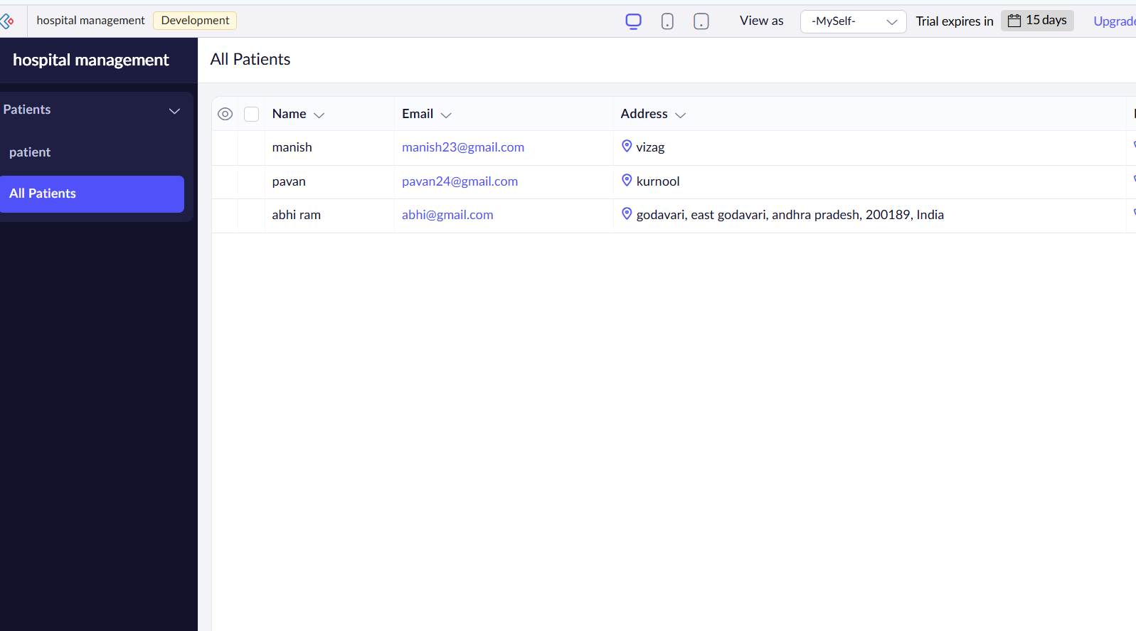

Result
A cloud-hosted application was successfully created and accessed as a SaaS service.

Experiment 2
Description: Create a simple cloud software application for Flight Reservation System using any Cloud Service Provider to demonstrate SaaS.

Aim
To design a cloud-based flight reservation system and deploy it under a SaaS model.

Procedure
- Select cloud platform for development.
- Create modules: User Login, Flight Search, Booking Form.
- Connect backend storage (cloud database).
- Deploy the system as a service.
- Test booking and search flows.
Output:
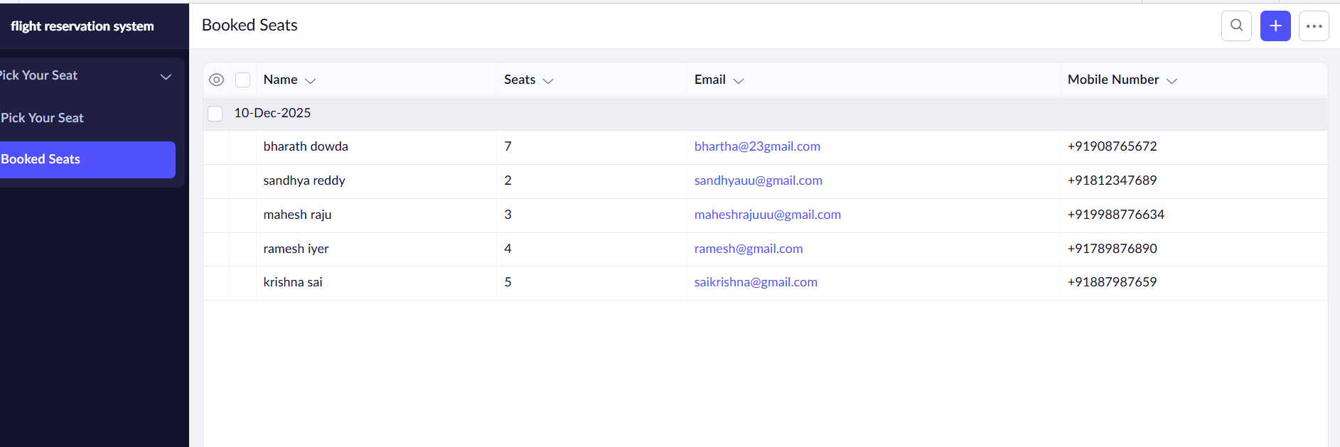

Result
The flight reservation system worked successfully with cloud-based deployment.

Experiment 3
Description: Create a simple cloud software application for Property Buying & Rental process (In Chennai city) using any Cloud Service Provider to demonstrate SaaS.

Aim
To build a cloud-enabled property buying and rental portal and publish it as SaaS.

Procedure
- Create modules: Property Listings, Filters, Contact Owner.
- Use cloud database for storing listings.
- Deploy application on cloud platform.
- Test property search and inquiry features.
Output:
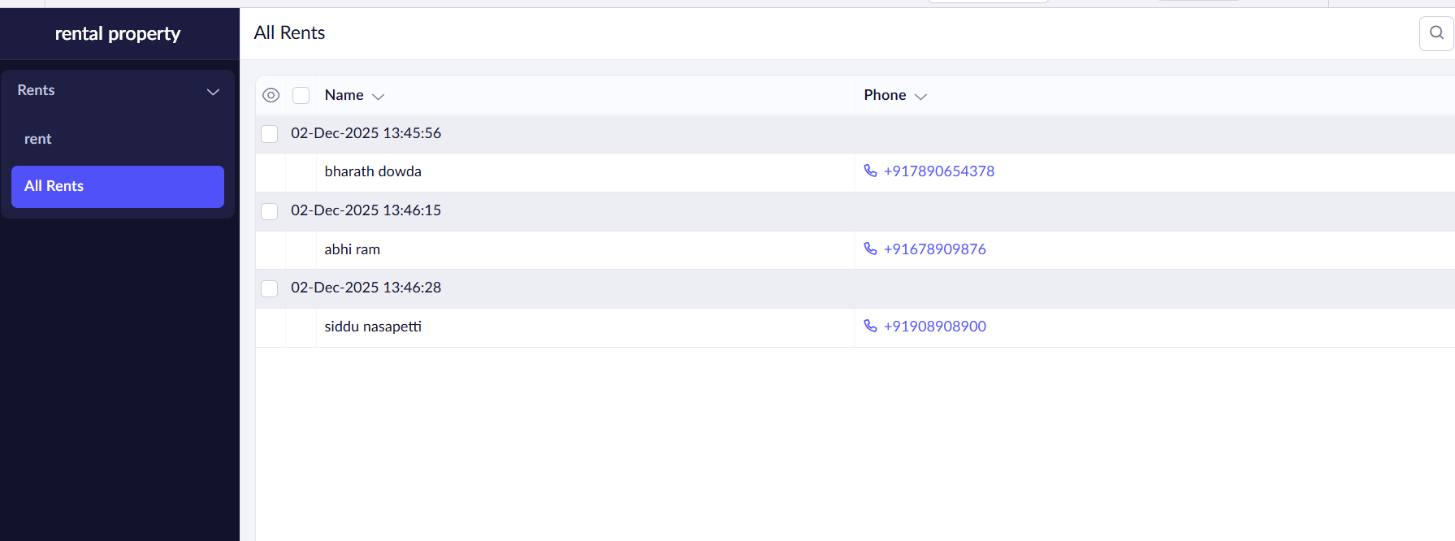

Result
A cloud-hosted property management system was created and deployed successfully.

Experiment 4
Description: Create a simple cloud software application for Car Booking Reservation System using any Cloud Service Provider to demonstrate SaaS.

Aim
To implement and deploy a car booking reservation system using a SaaS model.

Procedure
- Create booking modules: Car List, Availability Check, Booking Form.
- Store data in cloud database.
- Deploy application as a service.
- Test booking workflow.
Output:
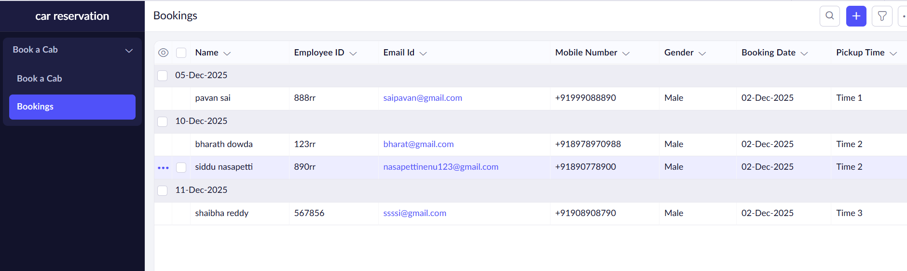

Result
Car booking system was successfully deployed and made accessible as SaaS.

Experiment 5
Description: Create a simple cloud software application for Library book reservation system for SIMATS library using any Cloud Service Provider to demonstrate SaaS.

Aim
To create a cloud-based library reservation platform and host it as a SaaS application.

Procedure
- Create modules: Book Search, Reservation Panel, Issue Request.
- Store book inventory in cloud database.
- Deploy the system on a cloud platform.
- Test book search and reservation features.
Output:
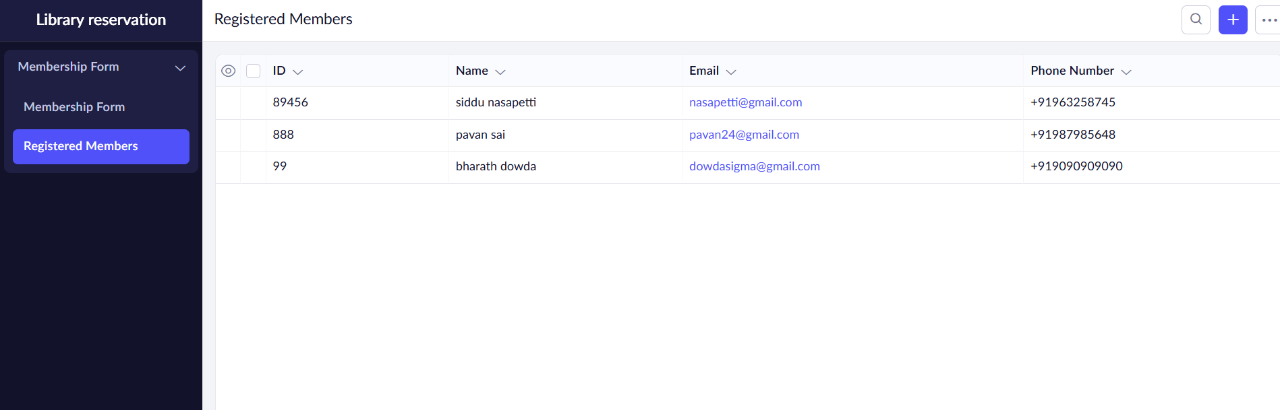

Result
Library reservation system was successfully created and deployed as SaaS.

